**REFLECTIONS**

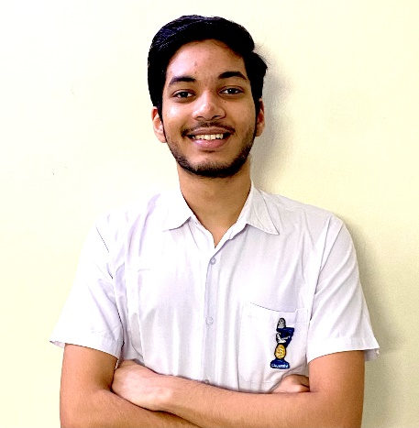

Being elected as Head Boy of Indian Language School was something I dreamt of since my early years in school. And what a year my fate decided to grant those wishes.

2020 has proven to be a year with a difference. We cannot reflect on this year without mentioning the Covid-19 pandemic and all its effects. It has taught us patience, love, and care for the less fortunate. It has also taught us how to be stronger yet kinder. This pandemic period has also shown how helpless and insignificant we are. None of us would have expected things to have played out this way, but at the end of it, here we are. To give you a break from all of it, let me show how the students and staff of ILS tackled these challenges and still managed to have a great time.

I would like to commend the immense efforts put in by our teachers to get accustomed to using new software and helping us realize the idea of “Schooling from Home.” Due to their efforts, we could experience a seamless transition into online learning as they got us familiarized with Zoom, Google Classroom, TedEd lessons, Nearpod, and several other platforms to keep our learning interesting and uninterrupted.

Even these challenging times could not dampen the spirits of the students of ILS. Despite this sudden change in their lifestyle, students across all grades have adapted brilliantly to a new way of life with online learning. We ensured that even during the lockdown, our festive celebrations took place in the form of virtual special assemblies, whether it be for Independence Day, Diwali or Christmas. I would like to thank the head girl Saloni Khulle, and the Heads of various Committees for their constant support and willingness to help throughout the year.

This year will be uniquely remembered in the history of our school. We were able to carry out events which we wouldn’t have in a normal year. ILS held its first online elections, with creative and quirky blogs being used for campaigning. Its first online Prize Distribution was also conducted this year. We were glad to host talk shows related to Coronavirus and have special addresses from a Holocaust Survivor, counsellors, and other professionals. Students would lighten up our day in the morning assembly by showcasing talents such as cooking, decorating, and various essential life skills.

Although there is the disappointment of not being able to meet my friends and participate in activities in the last year of school, there is a lot I can look back upon and have fond memories of. The sincere efforts of our principal and teachers, coupled with the motivation of our students, have ensured that our esteemed academy continues to move forward with pride, overcoming any hurdles in its way.

I would like to thank my parents for their guidance and blessings throughout my life.

It has been an honour to serve as the Head Boy of Indian Language School, to have been its student for fourteen years, and have assumed various leadership roles over these years. This school is and will always be my home, the place where I made friends for a lifetime and became the person that I am today. I would like to conclude by saying to my juniors that you are part of a special institution that will support you no matter where you go in life, and I leave you with the responsibility of keeping the ILS Flag moving in the right direction and in all its senses, keep it Flying High.

TANMAY PILLA

(HEAD BOY)